EECE 5614 Reinforcement Learning

Project 2

Problem 1:

Results:

1. Vector-form Policy Iteration Technique
   1. 𝑝 = 0.025, 𝛾 = 0.99, 𝜃 = 0.01

Policy iteration converges at iteration #17

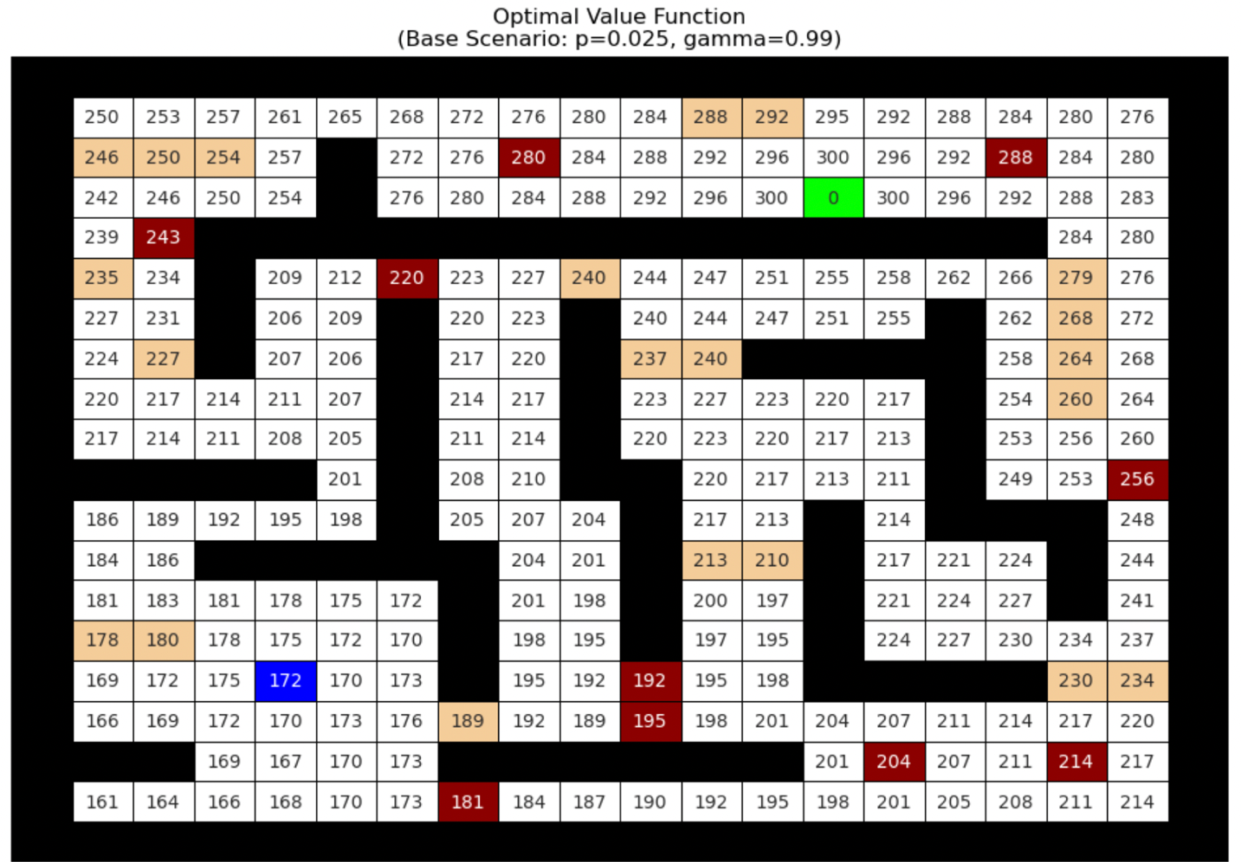

It can be observed from the above plot that the states closer or surrounding the goal state have higher value functions and as we move farther from the goal, the value function decreases, being the lowest around the cell defined as start for the agent.

Since the slip probability p=0.025 is very small, the agent is most likely to move in the intended direction than accidently slipping in the perpendicular directions and landing up in a bump cell or oil cell.

The discount factor = 0.99 is quite large in this scenario and hence the future reward for the goal state is highly valued, more than the immediate rewards that the agent receives.

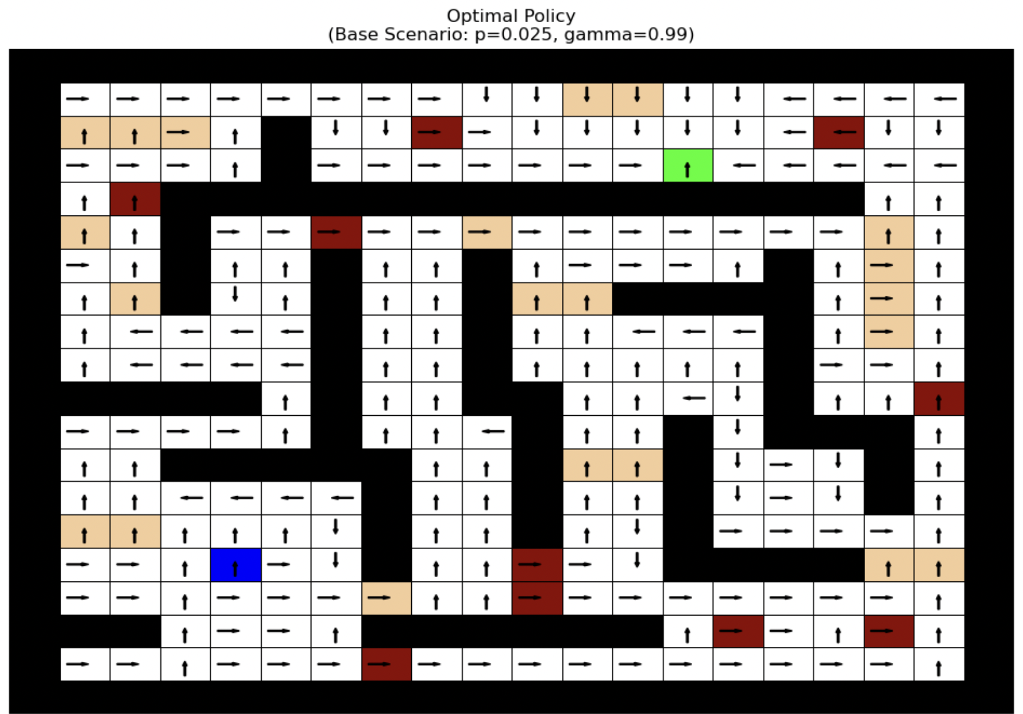

The above plot displays the optimal policy, optimal actions in each state that accumulate the highest number of rewards. The arrows in each cell generally pointing towards the goal including the detours because of the walls, bumps, and oil states.

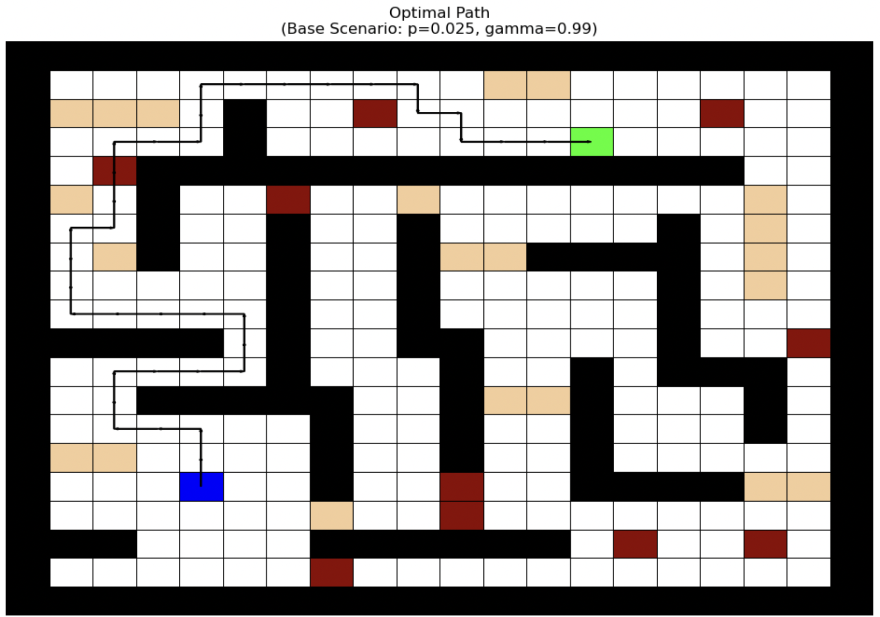

The above plot displays the optimal policy i.e. the shortest number of steps taken from the start state, taking actions to reach the goal state with the highest reward.

* 1. 𝑝 = 0.4, 𝛾 = 0.99, 𝜃 = 0.01 (Large Stochasticity Scenario)

Policy iteration converges at iteration #14

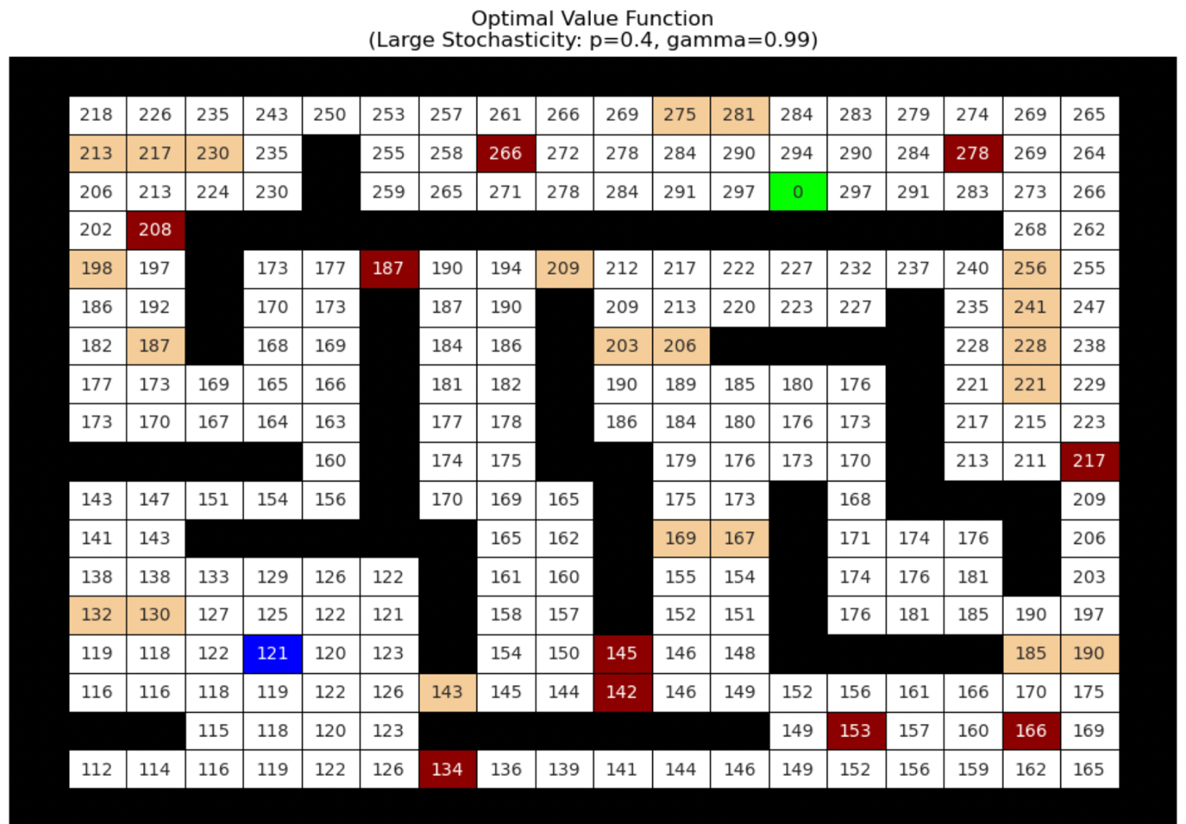

In this scenario, the probability of the agent moving in the intended direction is 1-p i.e. 60% whereas probability of slipping/moving in perpendicular directions is 20% in each direction. It can be observed from the above plot that the value functions are much lower than the base scenario. It happens because the agent must account for the increased risk of slipping probability into the oil and bump states i.e. more expected negative costs from the hazards. But the value functions do follow the trend where the values are higher around goal state and decrease near the start cell.

Since the discount factor remains the same, fairly high, the agent thinks that goal state gives the highest reward, despite the risk, and hence it incurs all the costs along the way until it reaches the goal.

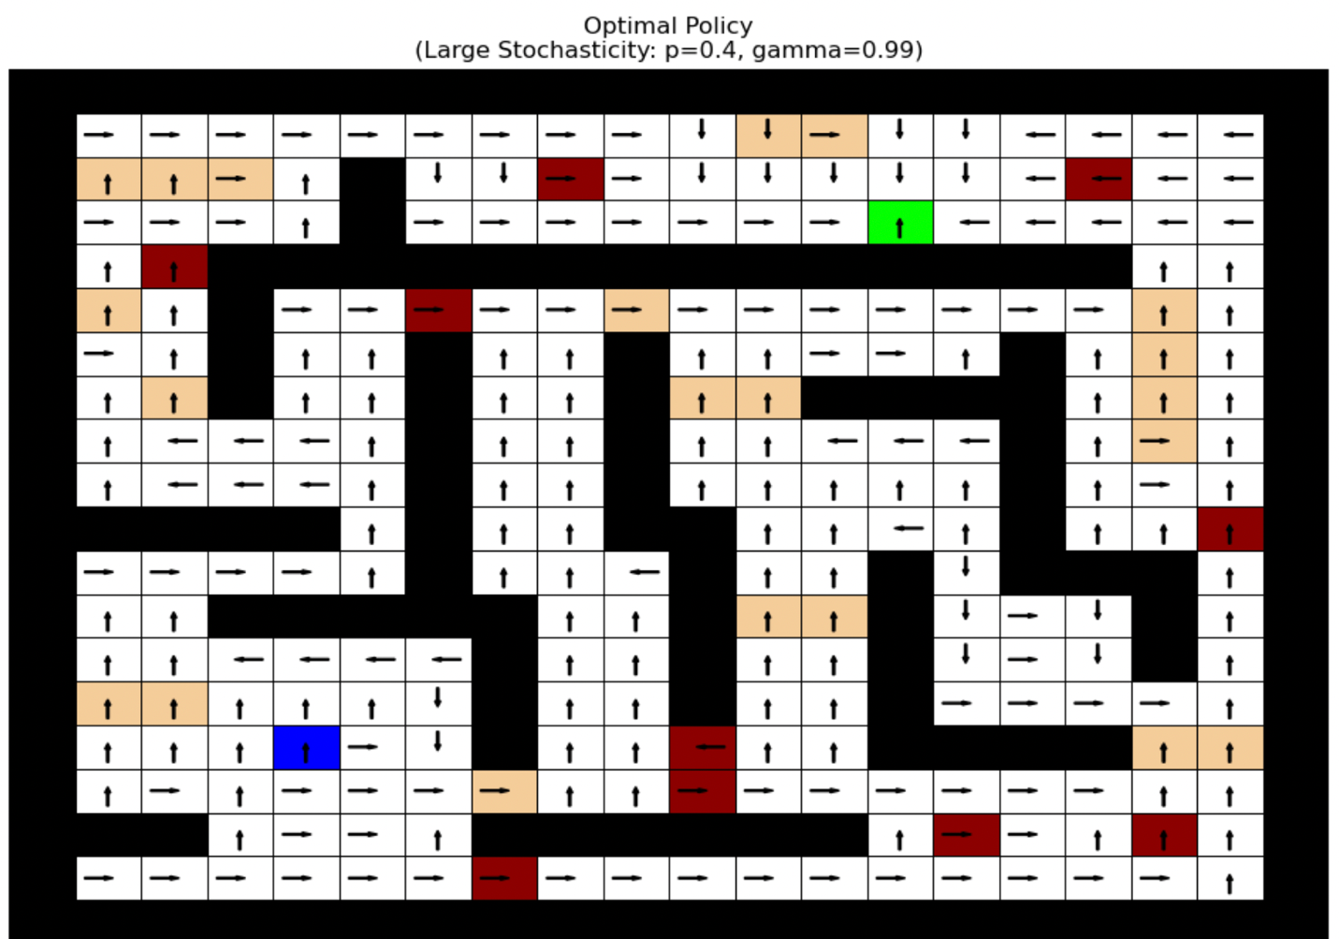

It can be observed that in this scenario too, the arrows generally point towards the goal state.

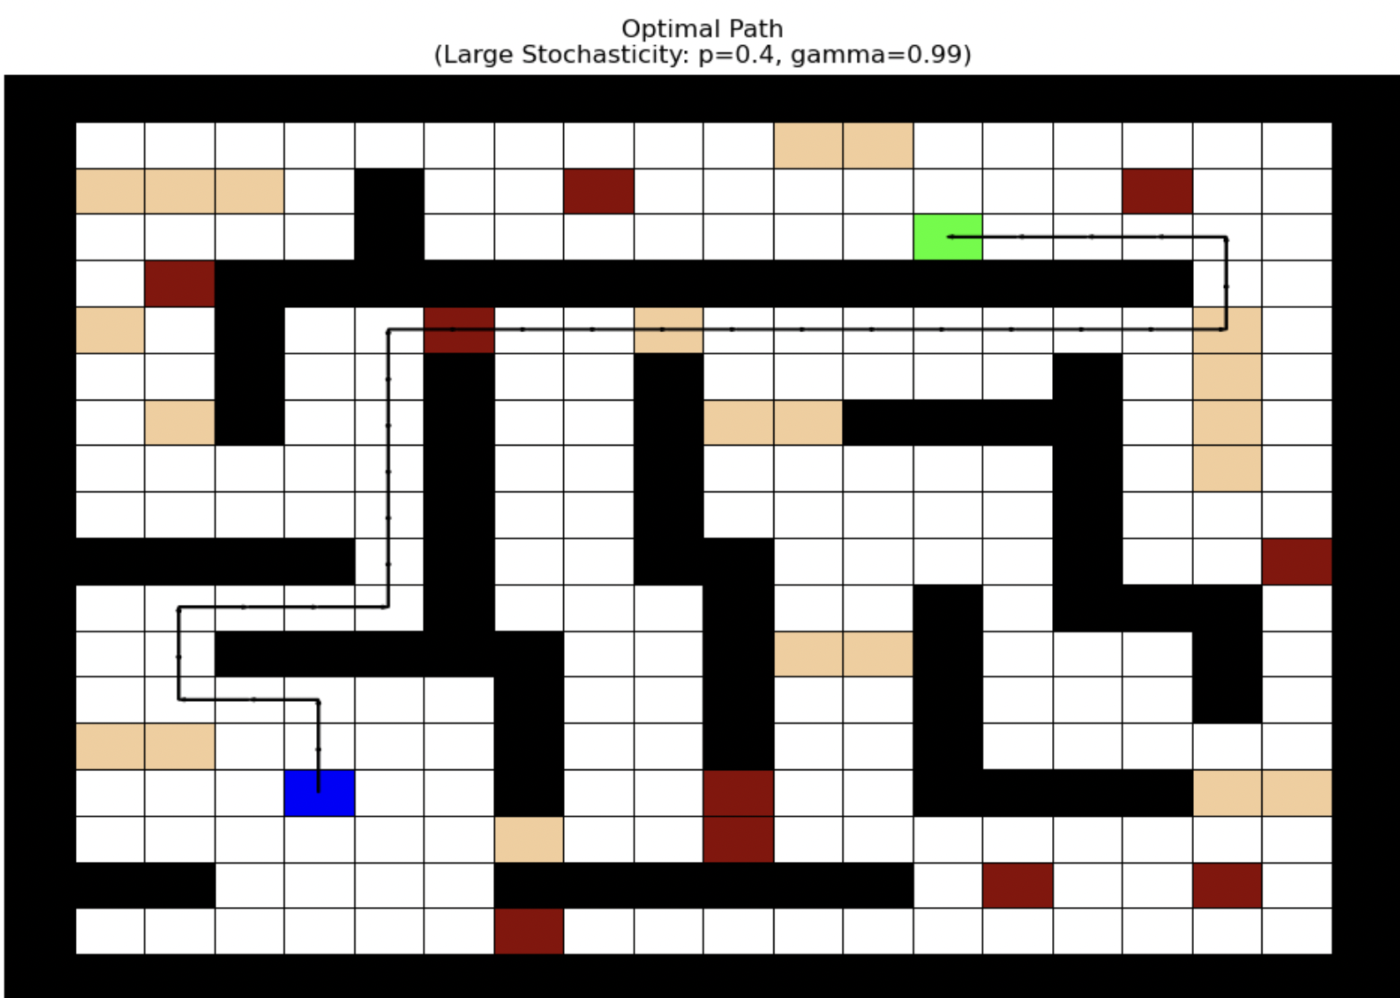

The optimal path seems to route through more number of oil and bump states as compared to the base scenario because of the increased risk of slipping in directions other than the intentional one.

* 1. 𝑝 = 0.025, 𝛾 = 0.5, 𝜃 = 0.01 (Small Discount Factor Scenario)

Policy iteration converges at iteration #6

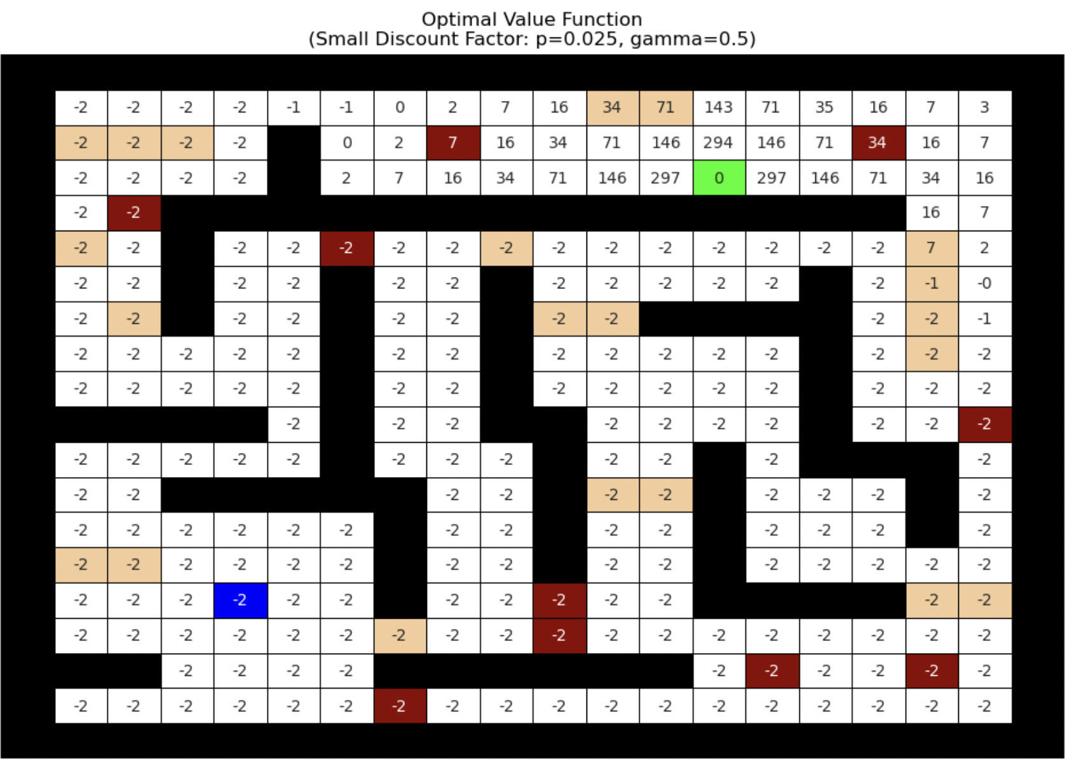

The discount factor has a smaller value resulting in heavy discounts for future rewards. The future reward of the agent moving towards the goal state diminishes very quickly. The step costs overshadow it. So the agent thinks that the best strategy would be to not travel, yielding negative or low values in most states. The agents thinks that the cost of travelling is greater than the discounted reward.

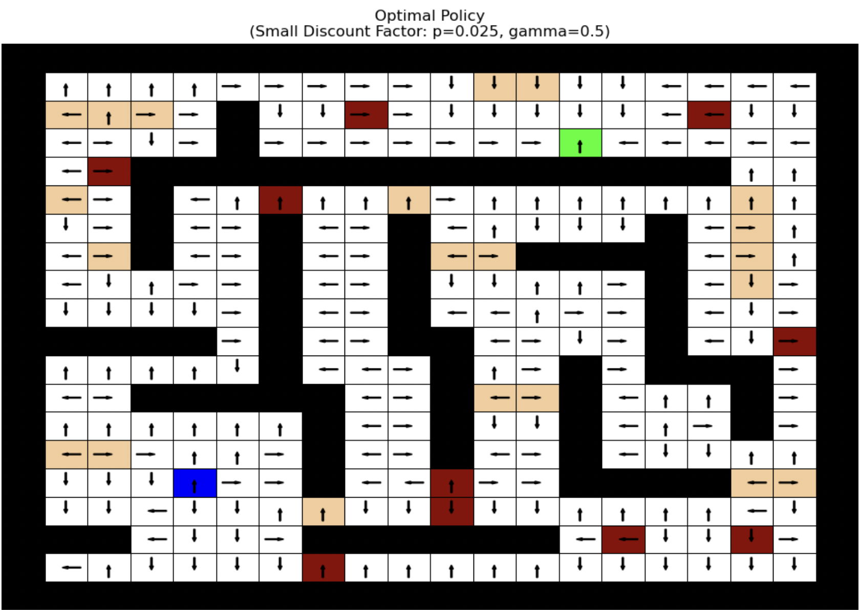

The arrows appear to point in random directions or stay around the start, because traveling far to the goal does not pay off once discounted so heavily.

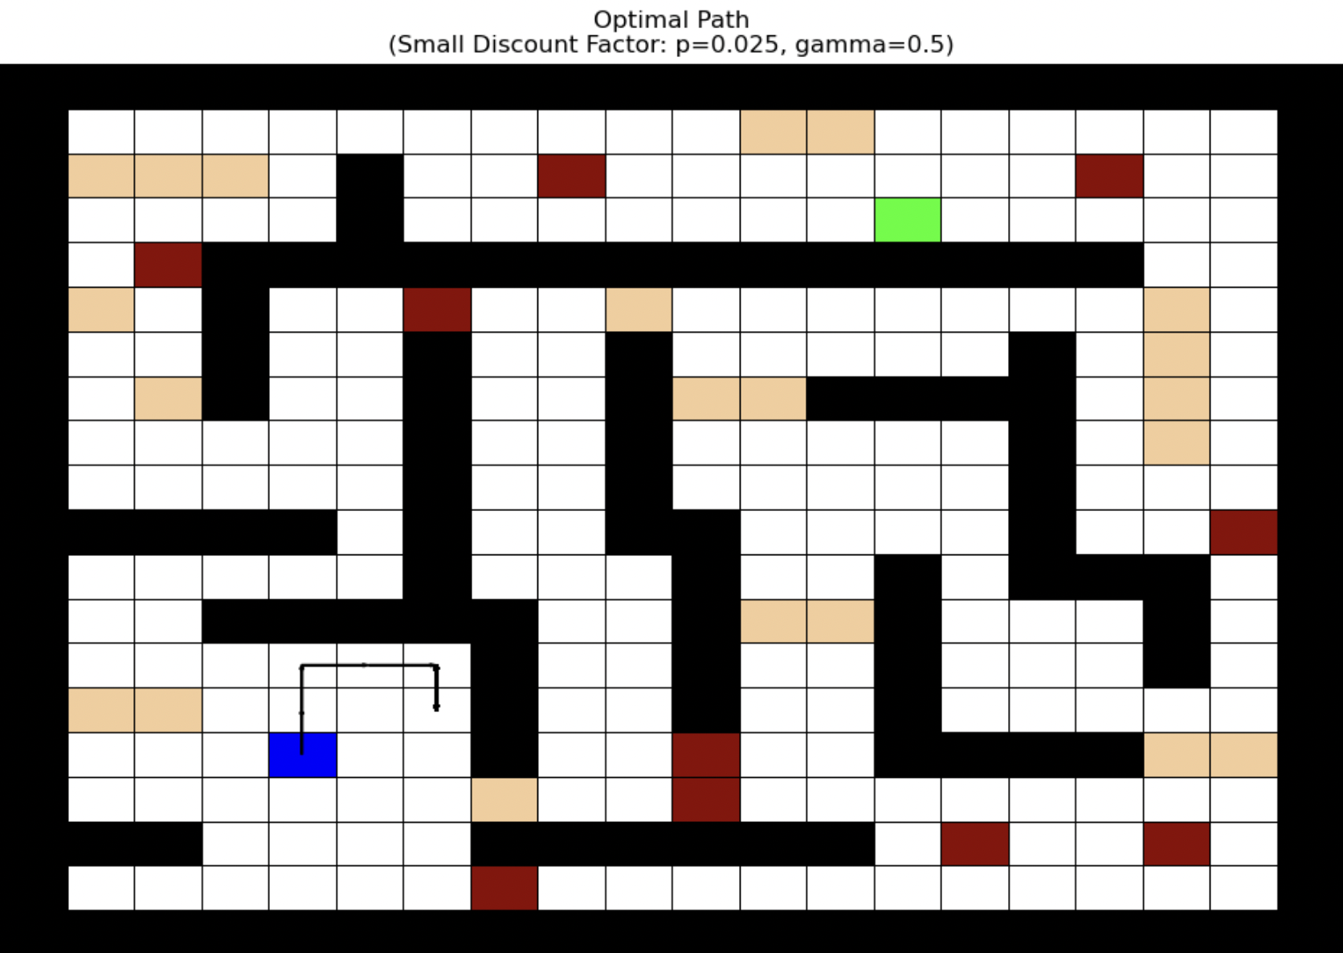

When the discount factor is small, the agent places more importance on the immediate reward than the future ones. The agent feels that the cost the taking each step (even stepping into a regular cell of -1) is too large to keep going for the goal state reward of 300. With a discount factor of 0.5 the agent thinks that each step in the future is worth only half of the step before it. So, the optimal path ends abruptly in (3, 12).

1. Vector-form Value Iteration Technique
   1. 𝑝 = 0.025, 𝛾 = 0.99, 𝜃 = 0.01 (Base Scenario)

Value iteration converges at iteration # 52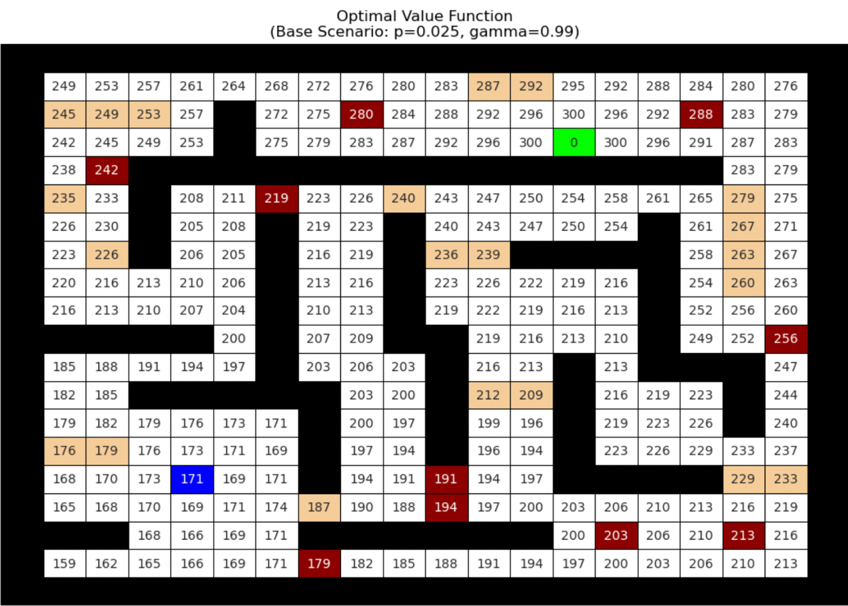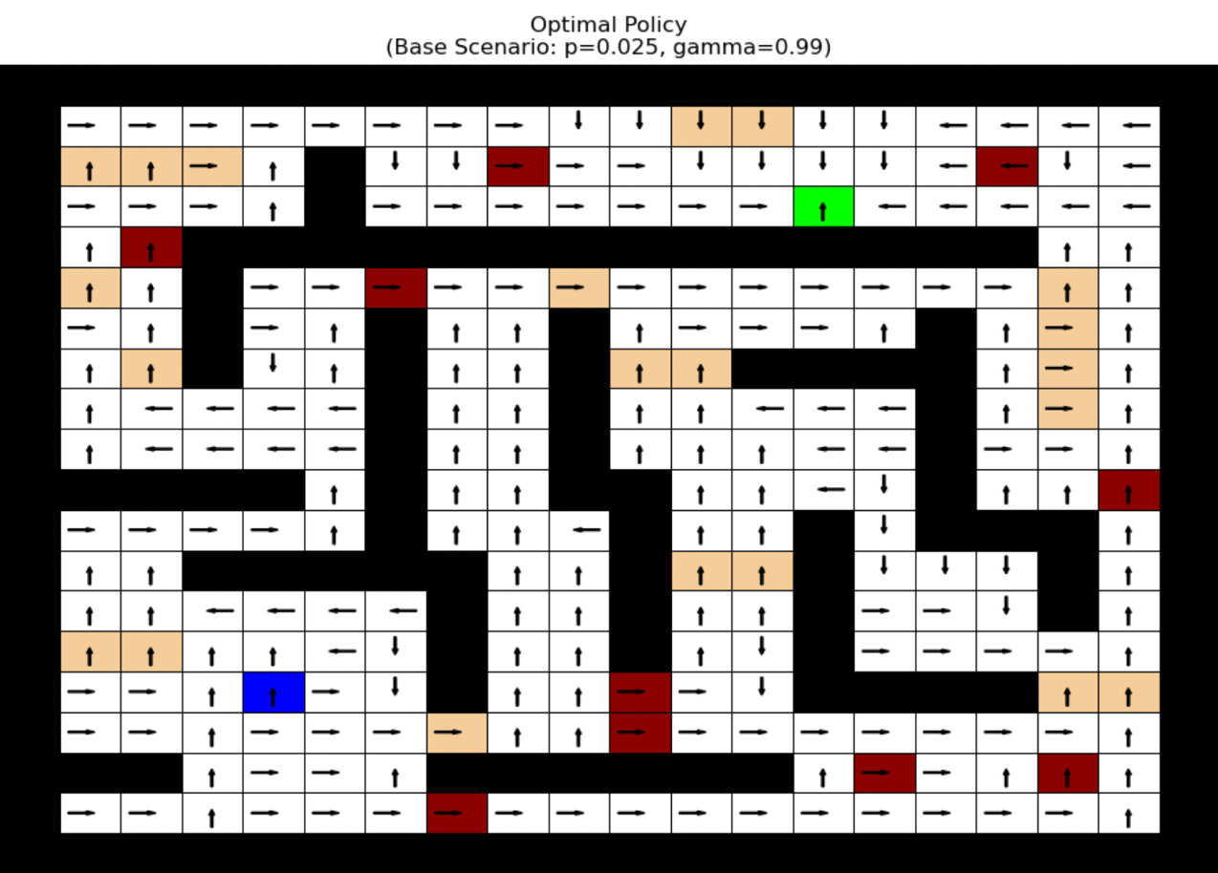

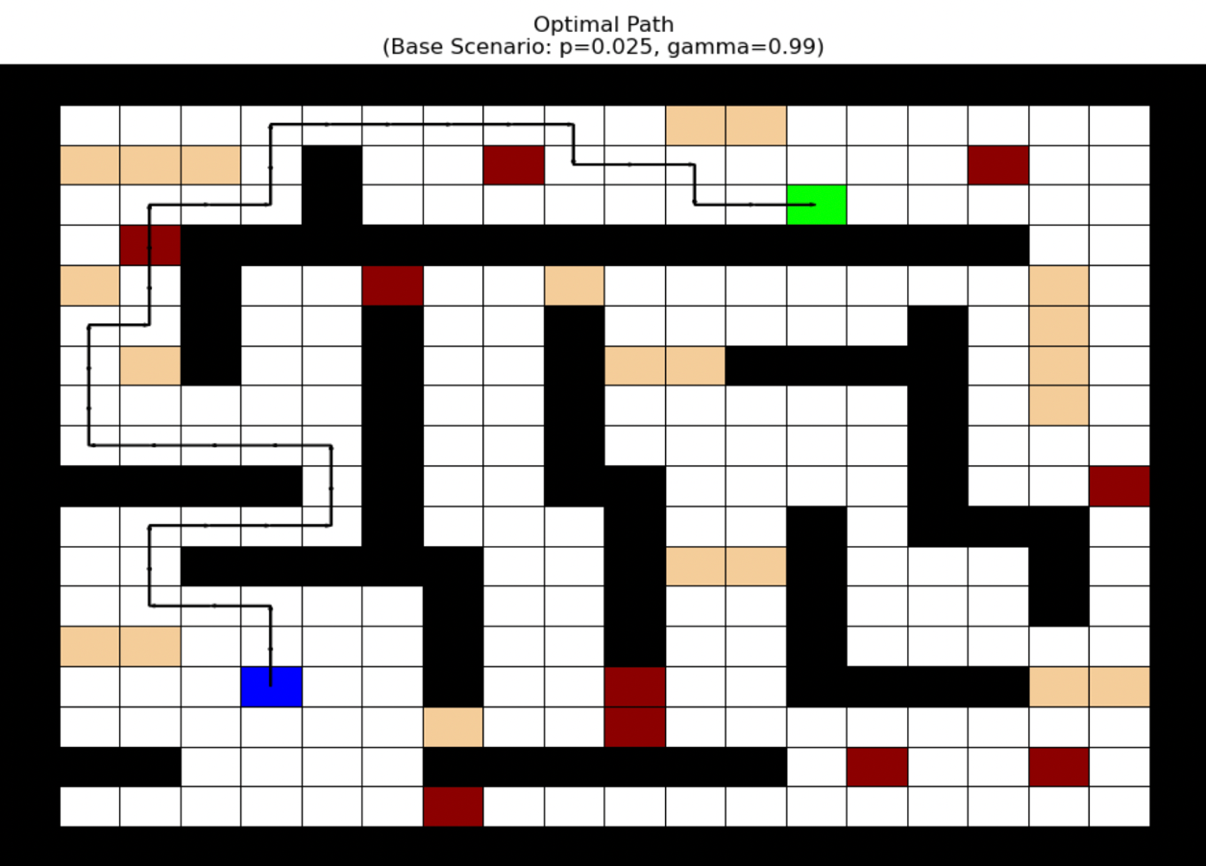

* 1. 𝑝 = 0.4, 𝛾 = 0.99, 𝜃 = 0.01 (Large Stochasticity Scenario)

Value iteration converges at iteration #110

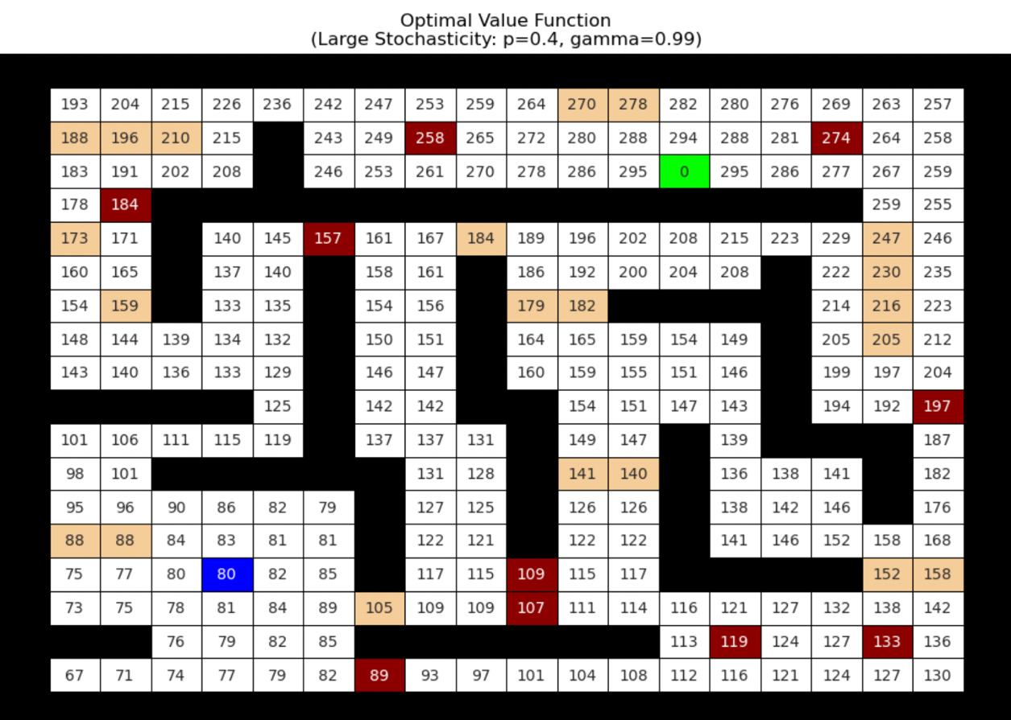

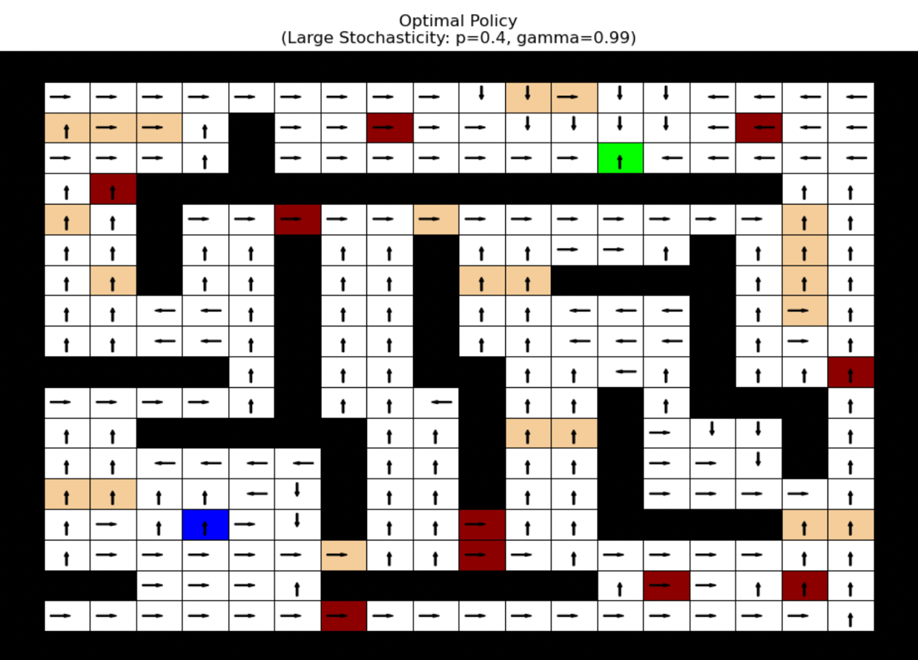

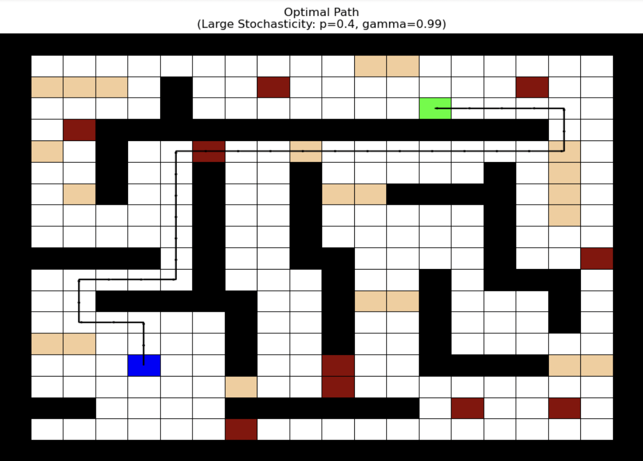

* 1. 𝑝 = 0.025, 𝛾 = 0.5, 𝜃 = 0.01 (Small Discount Factor Scenario)

Value iteration converges at iteration #15

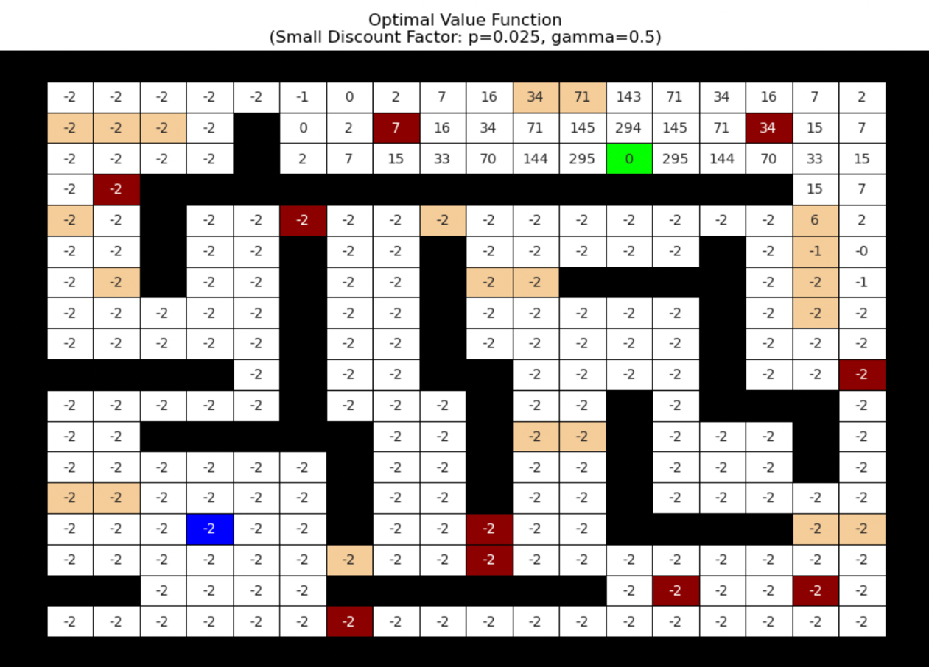

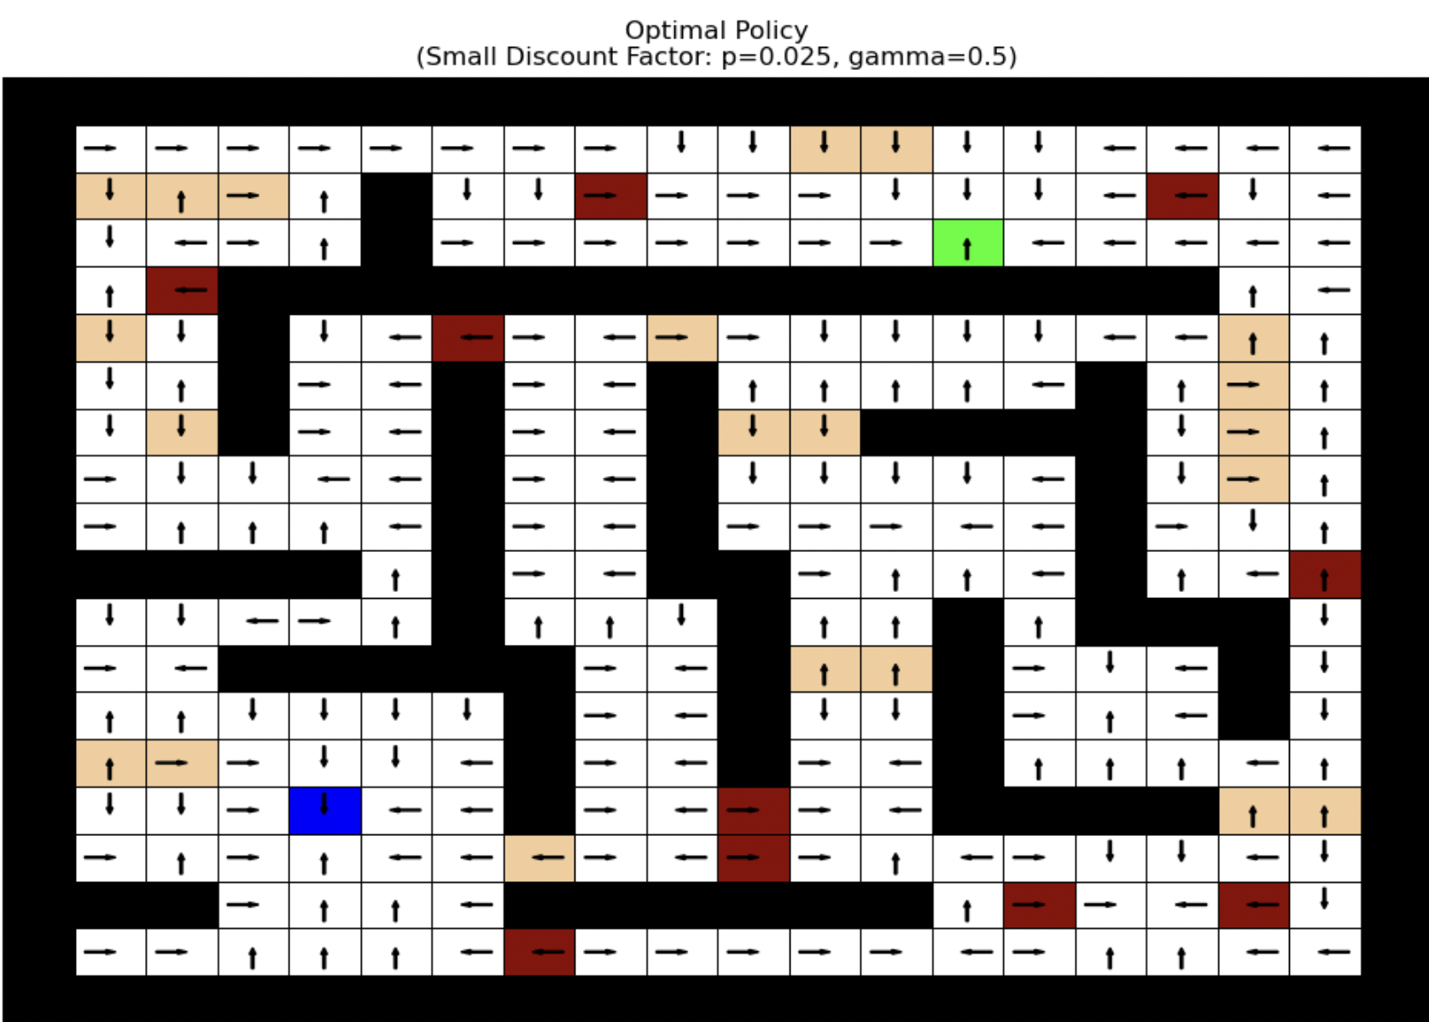

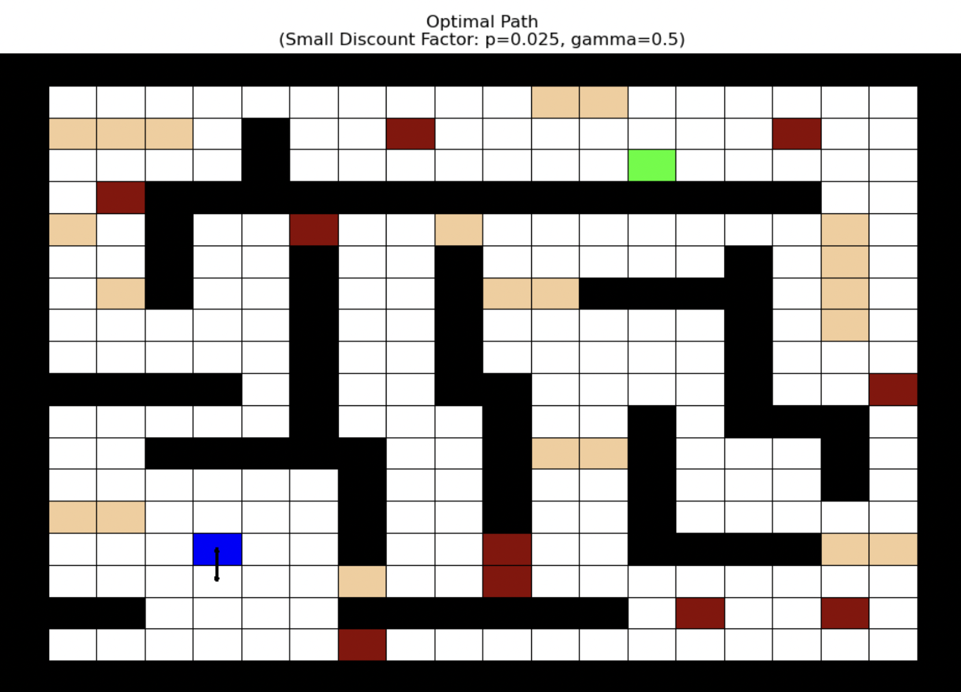

Overall, the results obtained with Value iteration technique are similar to the results obtained with policy iteration technique, but they differ in convergence speed, and the impact of changing discount factor and slipping probability.

* From the number of iterations reported for both techniques and in each of the scenarios, it can be observed that policy iteration tends to converge in fewer iterations compared to value iteration, especially in scenarios with a higher discount factor or high slipping probability. Value iteration, while conceptually simpler, often requires many more iterations for the values to propagate through the state space.
* In both the techniques, results are significantly impacted by the value of discount factor. With higher values of 𝛾, the future rewards are given more importance and hence the agent finds the optimal path to reach the goal even if the path may be longer. But with a lower discount factor, the agent gives more importance to the immediate costs and rewards. If the immediate step cost is too high, the agent even fails to reach the goal state, as in the results of “Small Discount Factor” scenario can be observed.
* For both techniques, it can be observed that the larger stochasticity i.e. the slipping probability lowers the overall state values because the agent must account for the risk of unintended moves into penalty cells.

Problem 2:

Results:

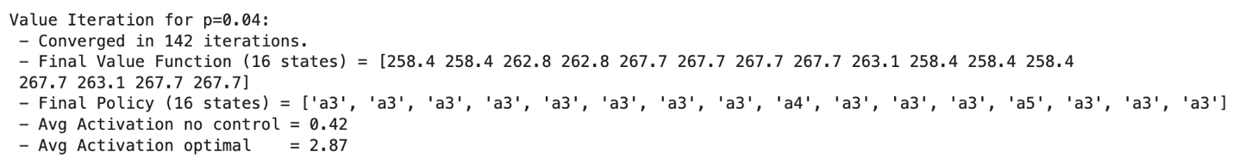

It can be observed from the final policy that the action a3 where gene p53 activates, is toggled in most of the states, with an occasional a4 and a5 in certain states. With low noise i.e. p=0.04, the controller can reliably keep more genes ON, achieving an average activation of nearly 3 genes at any time, whereas no control yields <1 on average. It took 142 iterations for the policy to converge.

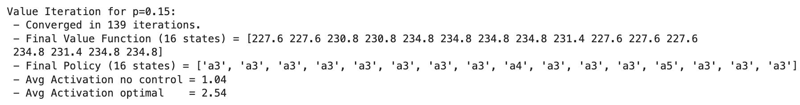

Increasing the noise from 0.04 to 0.15 forces more accidental flips OFF, so the maximum achievable average activation is a bit lower (2.53 vs. 2.87). However, the agent still exerts control by toggling the p53 gene (action a3) in majority states and occasional a4 and a5. It took 139 iterations for the value iteration technique to converge.

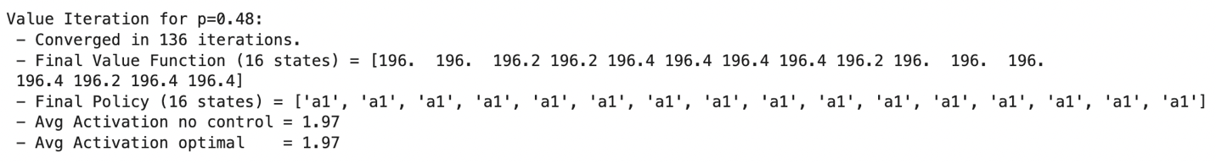

With a higher noise value i.e. p=0.48, attempts at forcing any gene ON have minimal impact because the system flips bits almost half the time anyway. The best policy ends up not toggling any genes (all a1). The average activation is approximately 2 for no control input as well as for optimal. This one required a total of 136 iterations to converge.

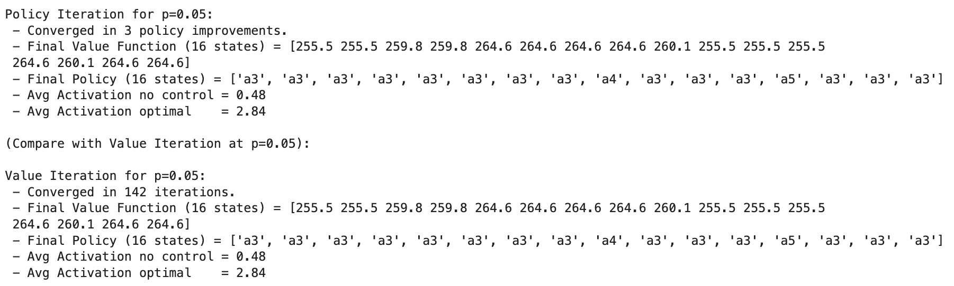

The optimal policy obtained in this scenario is very similar to the low noise scenario where p=0.04, also producing very close optimal value functions too. A point worth noting is that the number of iterations taken by policy iteration method (=3) are way lesser than it would have taken with value iteration (=142), eventually giving the same outcome.

To conclude, controlling the network with an appropriate action in each state dramatically increases the average number of ON genes when noise is small or moderate, but becomes nearly ineffective at very high noise levels. Both policy iteration and value iteration converge to the same solution in the low‐noise scenario (p=0.05), but policy iteration requires fewer improvements in that case.